1. A store is thinking about ordering smartphones for the next month. Purchase price is 2000 kn per phone, the selling price is 3000 kn per phone. They can order minimum of 23 and maximum of 30 phones. The expected demand is an interval between 25 and 30 phones.

|  |  |  |  |  |  |  |
| --- | --- | --- | --- | --- | --- | --- |
|  | 25 | 26 | 27 | 28 | 29 | 30 |
| 23 | 23,000.00 kn | 23,000.00 kn | 23,000.00 kn | 23,000.00 kn | 23,000.00 kn | 23,000.00 kn |
| 24 | 24,000.00 kn | 24,000.00 kn | 24,000.00 kn | 24,000.00 kn | 24,000.00 kn | 24,000.00 kn |
| 25 | 25,000.00 kn | 25,000.00 kn | 25,000.00 kn | 25,000.00 kn | 25,000.00 kn | 25,000.00 kn |
| 26 | 23,000.00 kn | 26,000.00 kn | 26,000.00 kn | 26,000.00 kn | 26,000.00 kn | 26,000.00 kn |
| 27 | 21,000.00 kn | 24,000.00 kn | 27,000.00 kn | 27,000.00 kn | 27,000.00 kn | 27,000.00 kn |
| 28 | 19,000.00 kn | 22,000.00 kn | 25,000.00 kn | 28,000.00 kn | 28,000.00 kn | 28,000.00 kn |
| 29 | 17,000.00 kn | 20,000.00 kn | 23,000.00 kn | 26,000.00 kn | 29,000.00 kn | 29,000.00 kn |
| 30 | 15,000.00 kn | 18,000.00 kn | 21,000.00 kn | 24,000.00 kn | 27,000.00 kn | 30,000.00 kn |

|  |  |  |  |  |  |  |  |  |  |  |
| --- | --- | --- | --- | --- | --- | --- | --- | --- | --- | --- |
|  | 8 | 9 | 10 | 11 | 12 | MIN | MAX | H | Laplace | CEV |
|  | 1/5 | 1/5 | 1/5 | 1/5 | 1/5 |  |  |  |  |  |
|  | 0,1 | 0,2 | 0,3 | 0,2 | 0,2 |  |  |  |  |  |
| 8 | 16 | 16 | 16 | 16 | 16 | 16 | 16 | 16 | 16 | 16 |
| 9 | 13 | 18 | 18 | 18 | 18 | 13 | 18 | 16 | 17 | 17.5 |
| 10 | 10 | 15 | 20 | 20 | 20 | 10 | 20 | 16 | 17 | 18 |
| 11 | 7 | 12 | 17 | 22 | 22 | 7 | 22 | 16 | 16 | 17 |
| 12 | 4 | 9 | 14 | 19 | 24 | 4 | 24 | 16 | 14 | 15 |
| 13 | 1 | 6 | 11 | 16 | 21 | 1 | 21 | 13 | 11 | 12 |
| 14 | -2 | 3 | 8 | 13 | 18 | -2 | 18 | 10 | 8 | 9 |
| 15 | -5 | 0 | 5 | 10 | 15 | -5 | 15 | 7 | 5 | 6 |
|  |  |  |  |  |  | 8 | 8 | 8 | 8 | 8 |

|  |  |  |  |  |  |  |
| --- | --- | --- | --- | --- | --- | --- |
| Matrix of regret | 8 | 9 | 10 | 11 | 12 | MAX |
| 8 | 0 | 2 | 4 | 6 | 8 | 8 |
| 9 | 3 | 0 | 2 | 4 | 6 | 6 |
| 10 | 6 | 3 | 0 | 2 | 4 | 6 |
| 11 | 9 | 6 | 3 | 0 | 2 | 9 |
| 12 | 12 | 9 | 6 | 3 | 0 | 12 |
| 13 | 15 | 12 | 9 | 6 | 3 | 15 |
| 14 | 18 | 15 | 12 | 9 | 6 | 18 |
| 15 | 21 | 18 | 15 | 12 | 9 | 21 |

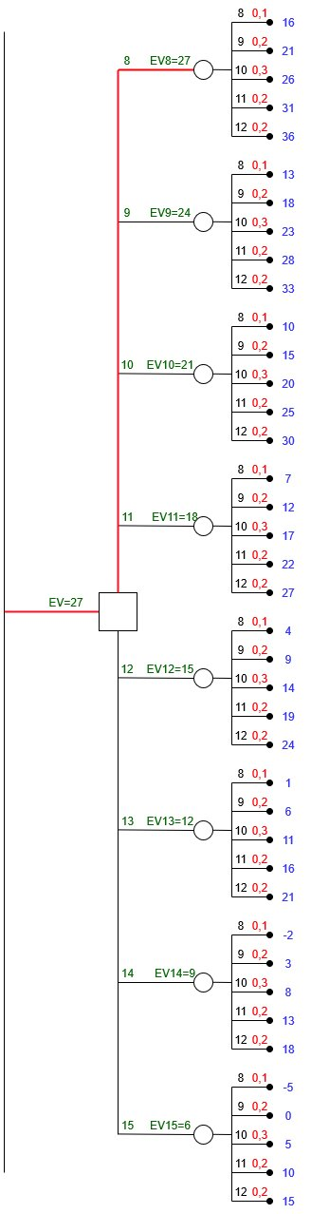

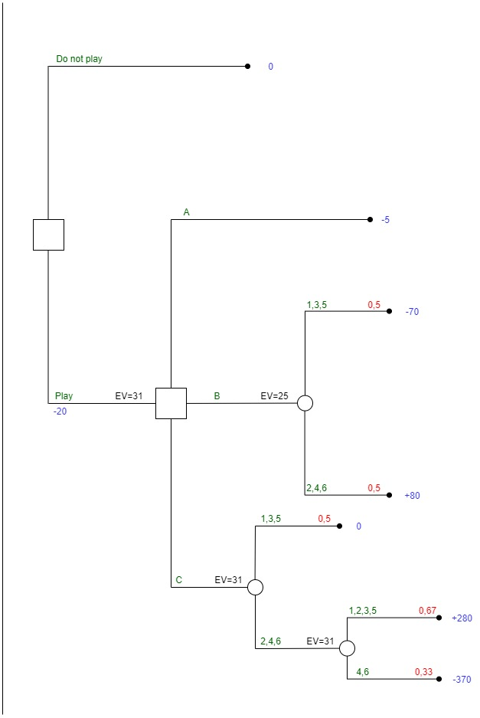

|  |  |  |  |  |  |  |  |  |  |
| --- | --- | --- | --- | --- | --- | --- | --- | --- | --- |
|  | 5000 | 2500 | 1000 | MIN | MAX |  |  | Laplace | CEV |
|  | 3/10 | 2/5 | 3/10 |  |  |  |  |  |  |
|  | 0.3 | 0.4 | 0.3 |  |  |  |  |  |  |
| Keep | 2000 | 2000 | 2000 | 2000 | 2000 | 2000 | 2000 | 2000 | 2000 |
| Spin | 5000 | 2500 | 1000 | 1000 | 5000 | 1400 | 3400 | 2800 | 2800 |

|  |  |  |  |  |
| --- | --- | --- | --- | --- |
| Matrix of regret | 5000 | 2500 | 1000 | Max |
| Keep | 3000 | 500 | 0 | 3000 |
| Spin | 0 | 0 | 1000 | 1000 |

The better option would be to spin.

